

Lab 5: Two table queries – SQL Joins on Akira

Information School, University of Wisconsin-Madison

**Deliverables:** This word document with questions answered uploaded to Canvas.

**Description:** This lab allows you to practice 2 table queries

**Note: Make sure you use VPN if you are using wireless connection.**

**INSTRUCTION: How to provide SQL query answers.**

To ensure you get full credit for each SQL query problem please provide one screenshot that meets the following criteria:

1. You show the full query in the screenshot
2. You DO NOT need to show all the Results in the Results Grid (you can make this part smaller!)
3. We grade based on the query text and the number of results for the query shown in the Action Output bar. You need to show the number of rows produced by the query in the Action Output bar. To do so, clear the history so your number of results shows in the top line of the output.

## Problem Set 1: One Table Queries with New Accessories

Please **paste the SQL statement and a copy of the results** under each question (some of the queries may have null results). Make sure you execute each statement before you submit.

**Query 1.1: (VRG database from Lab 3) List the first three customers from Washington State in the Washington table.**

Skill: LIMIT/TOP

Hints: https://www.w3schools.com/sql/sql_top.asp

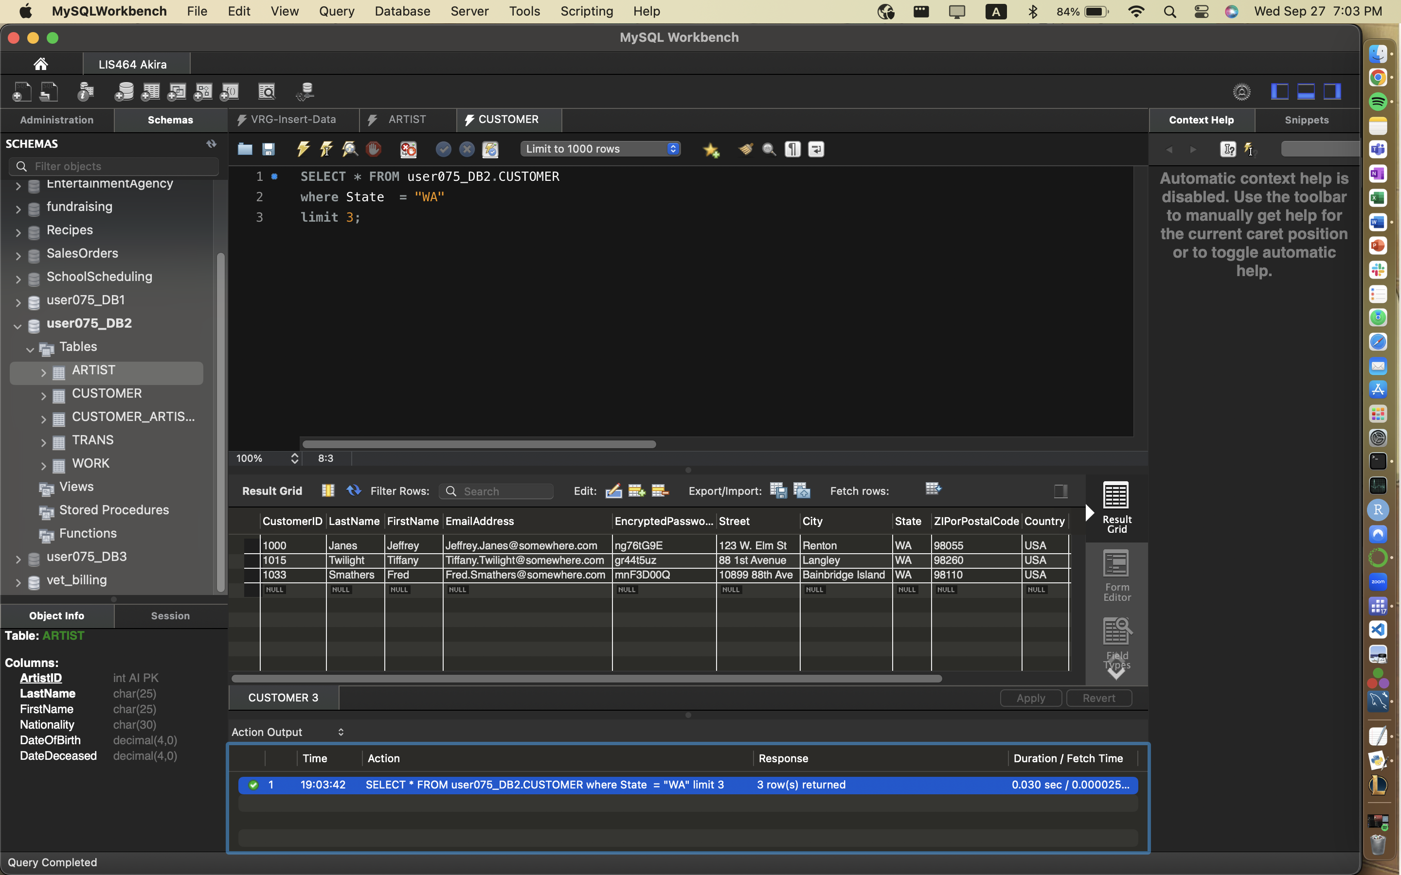

**Query 1.2: (VRG database from Lab 3) Count the number of customers from Washington State or California.**

Skill: COUNT, IN (COUNT is an aggregate function)

Hints: [https://www.w3schools.com/sql/sql_count_avg_ sum.asp](https://www.w3schools.com/sql/sql_count_avg_%09sum.asp); https://www.w3schools.com/sql/sql_in.asp

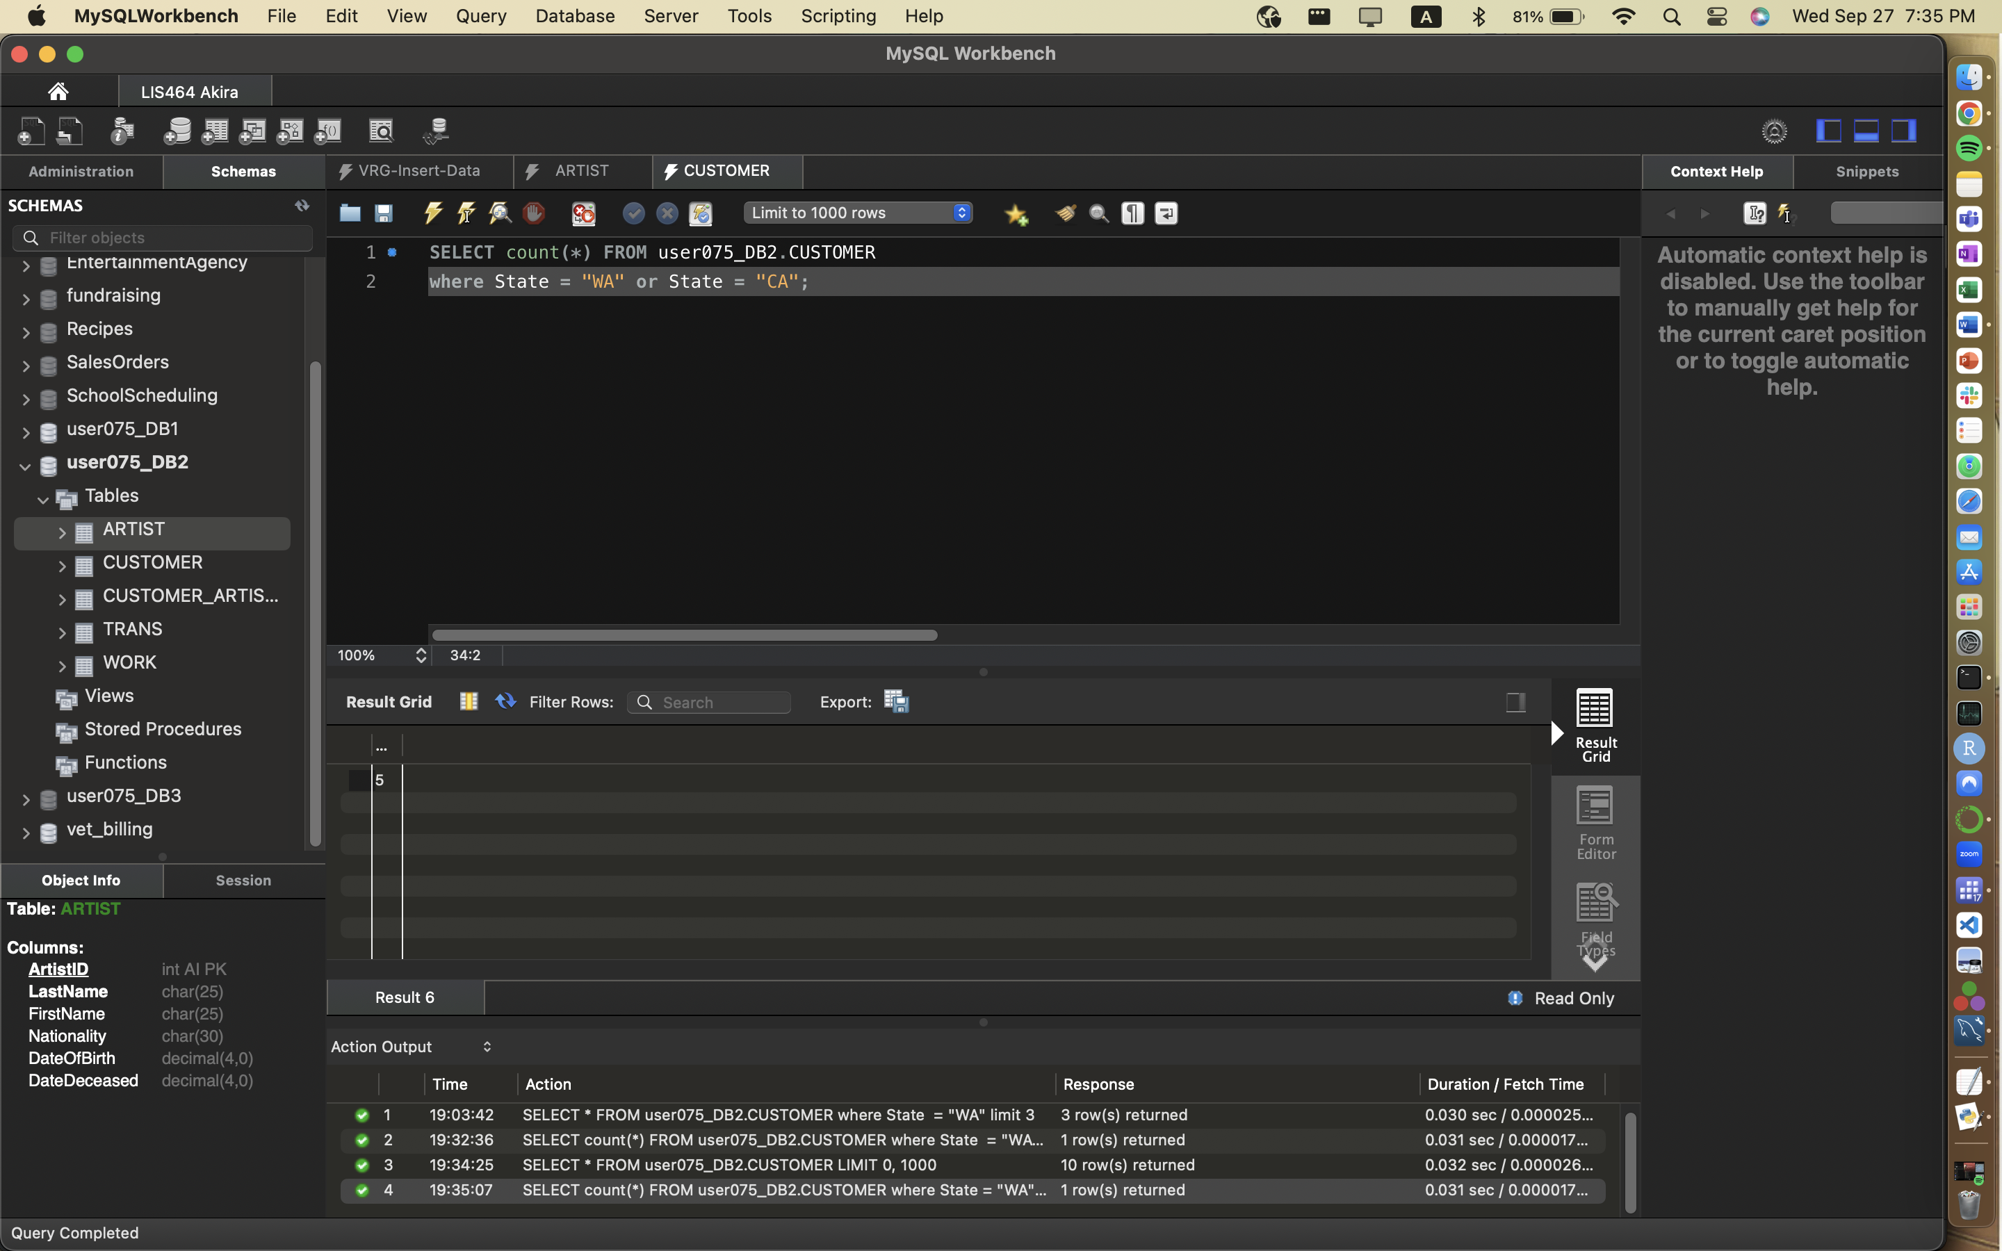

**Query 1.3** **(VRG database from Lab 3) List all the titles of prints as “Print_Title”. Also list the medium for each to show that you have only selected prints. Separately - How many total prints were listed in your results set?**

Skill: AS, LIKE, WILDCARD

24 results

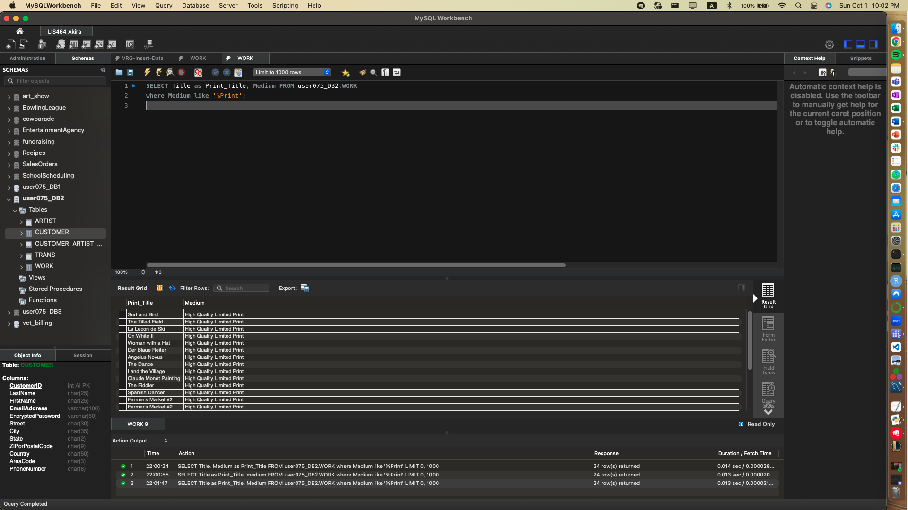

**Query 1.4.** **(VRG database from Lab 3) What is the average, maximum and minimum Sales Price of each transaction for VRG?**

Skill: AVG, MAX, MIN(AVG is an aggregate function)

1 result of 3 columns

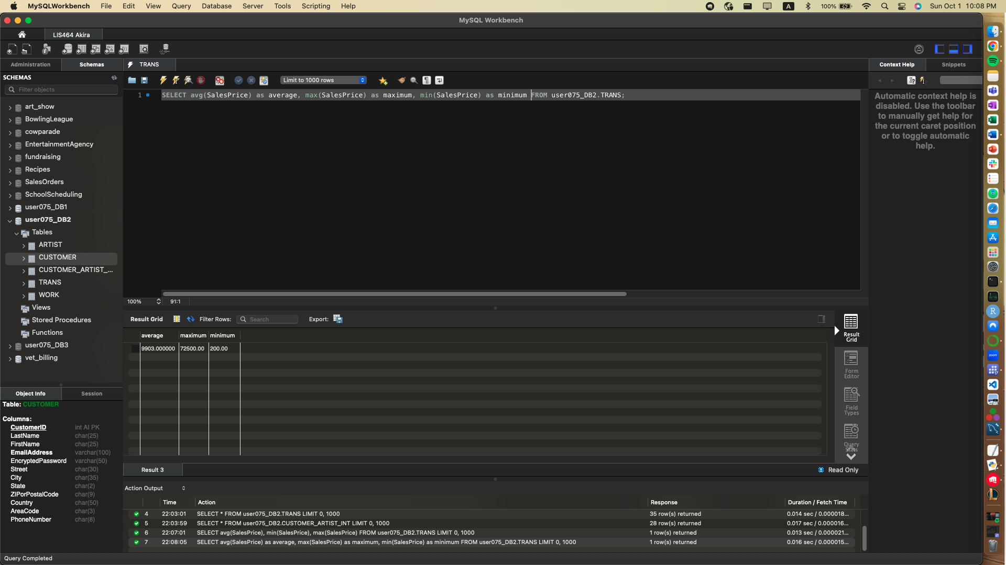

## Problem Set 2: Two Table Query Basics

Remember basic syntax

SELECT

FROM

INNER JOIN

ON

Which two tables do you need to answer this question?

What is the PK/FK pair between them?

**Query 2.1 (VRG database from Lab 3) For each transaction, list the customer names, transaction date and the sales price. How many rows were returned.** 25 rows returned

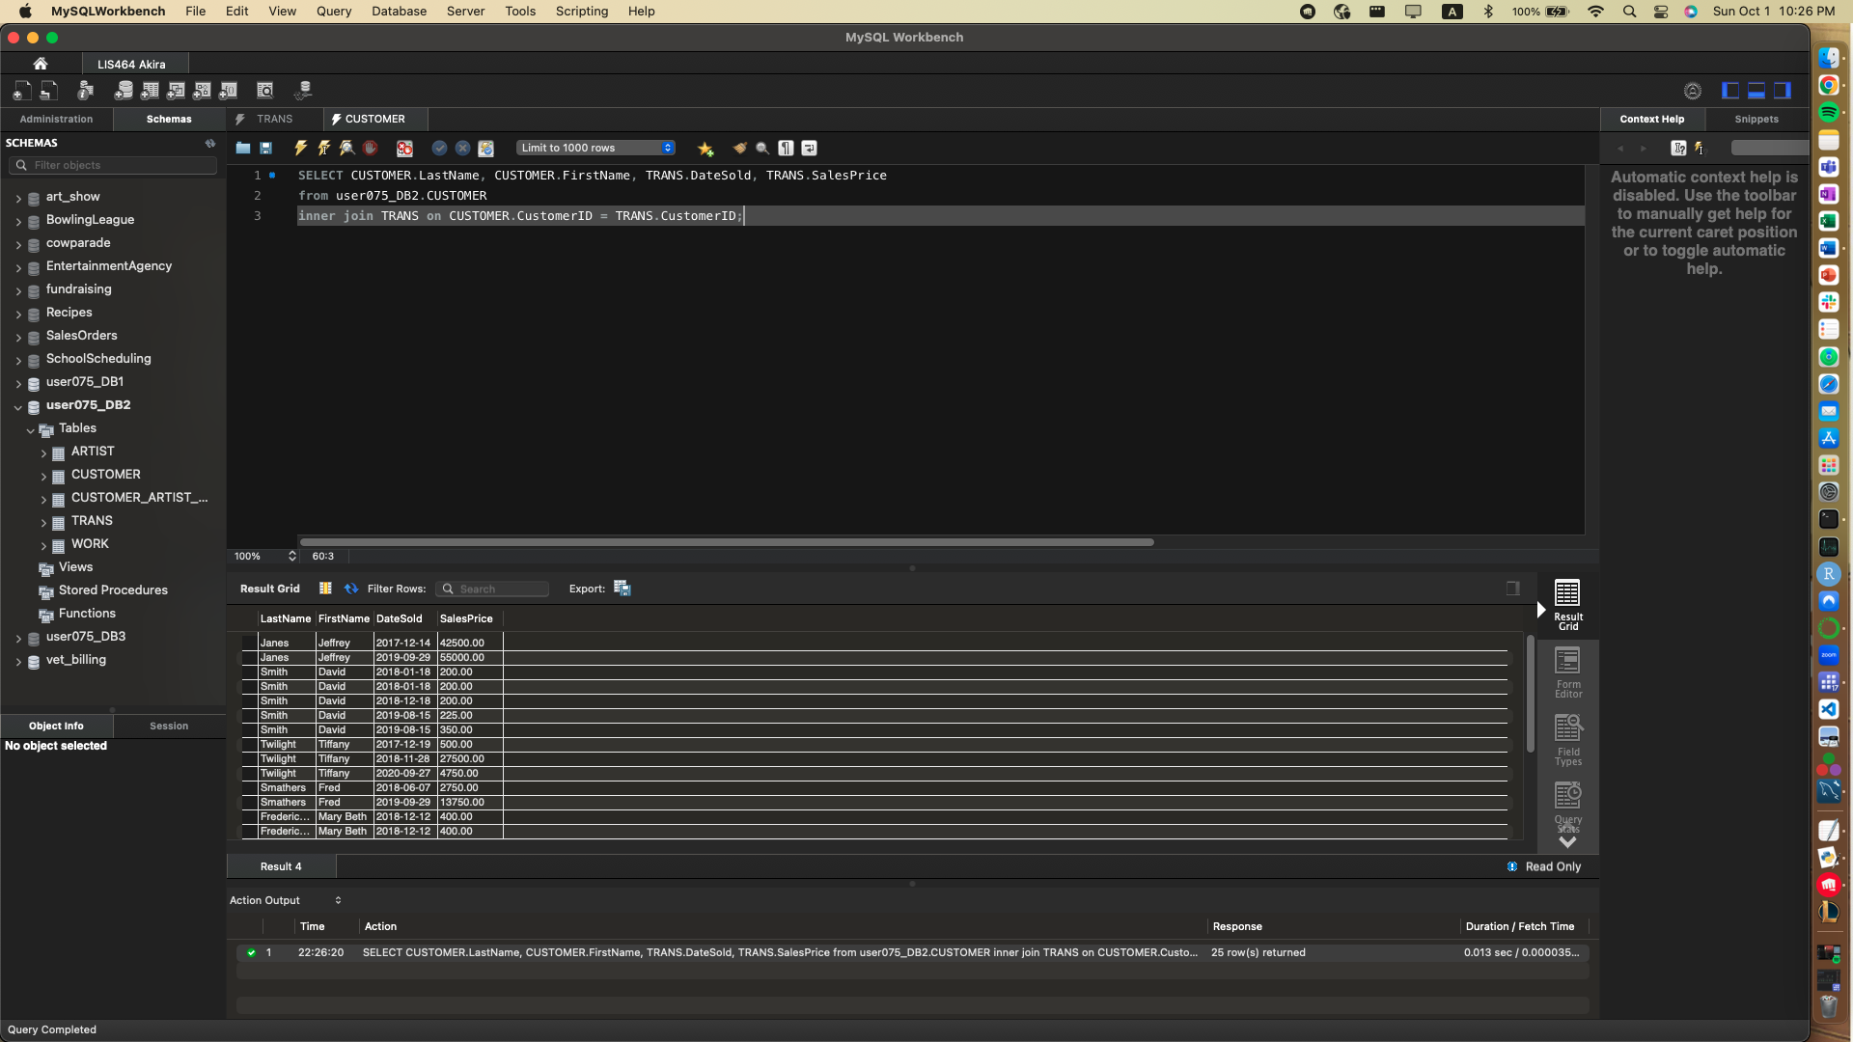

**Query 2.2. (VRG database from Lab 3) List all the names of artists and the names of their works. How many rows are returned?** 34 rows returned

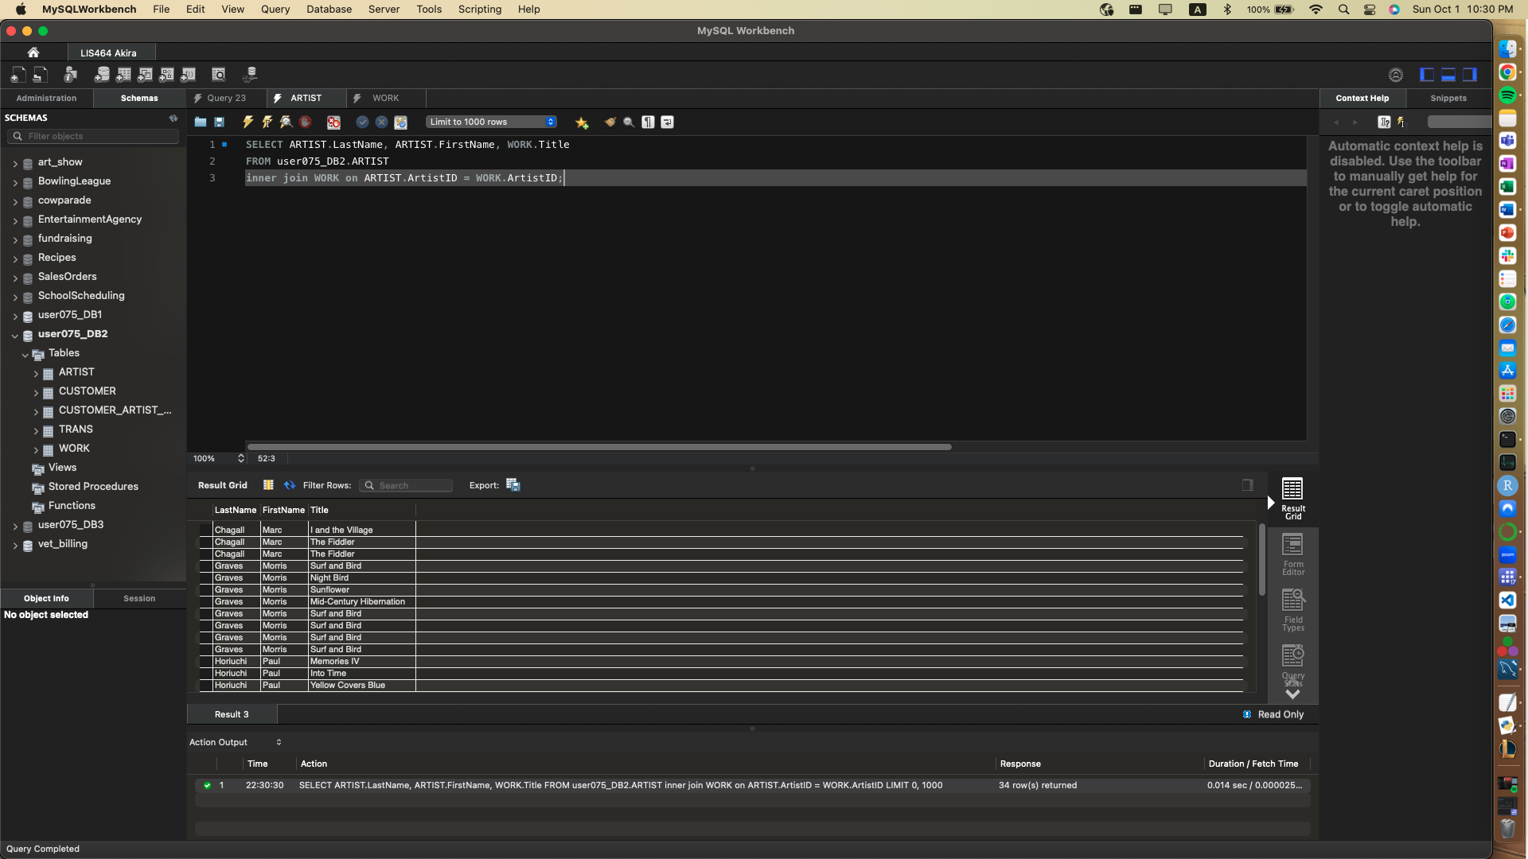

**Query 2.3 (Bowling League Database on Akira) List the bowling team name and the names of all the members.** 32 rows.

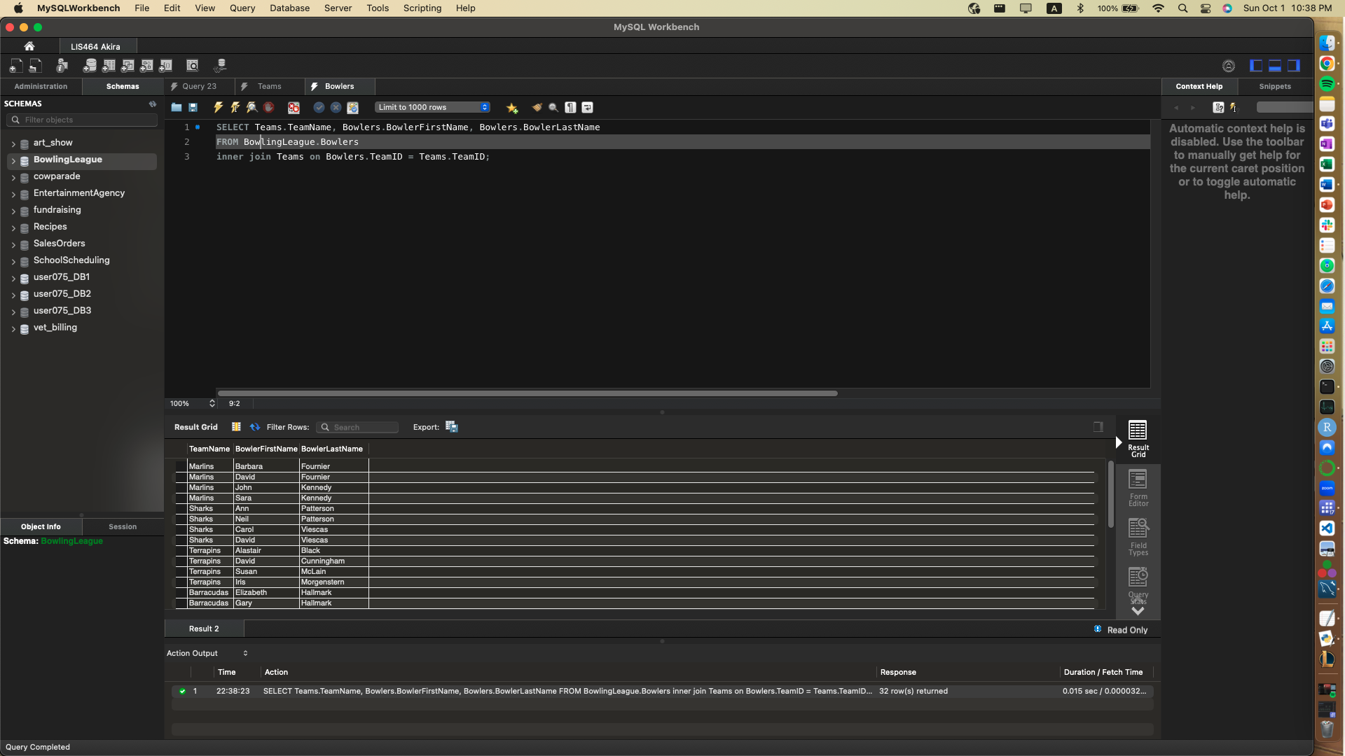



## Problem Set 3: Two Tables Accessorized

**Query 3.1: (VRG database from Lab 3) - Please list the total amount (SUM) paid by customers whose first name start with letter S. Make sure you list the first name, last name and total amount paid by each customer. 1 row.**

2 table query with skills SUM and WHERE, WILDCARDS

Hints: https://www.w3schools.com/sql/sql_count_avg_sum.asp

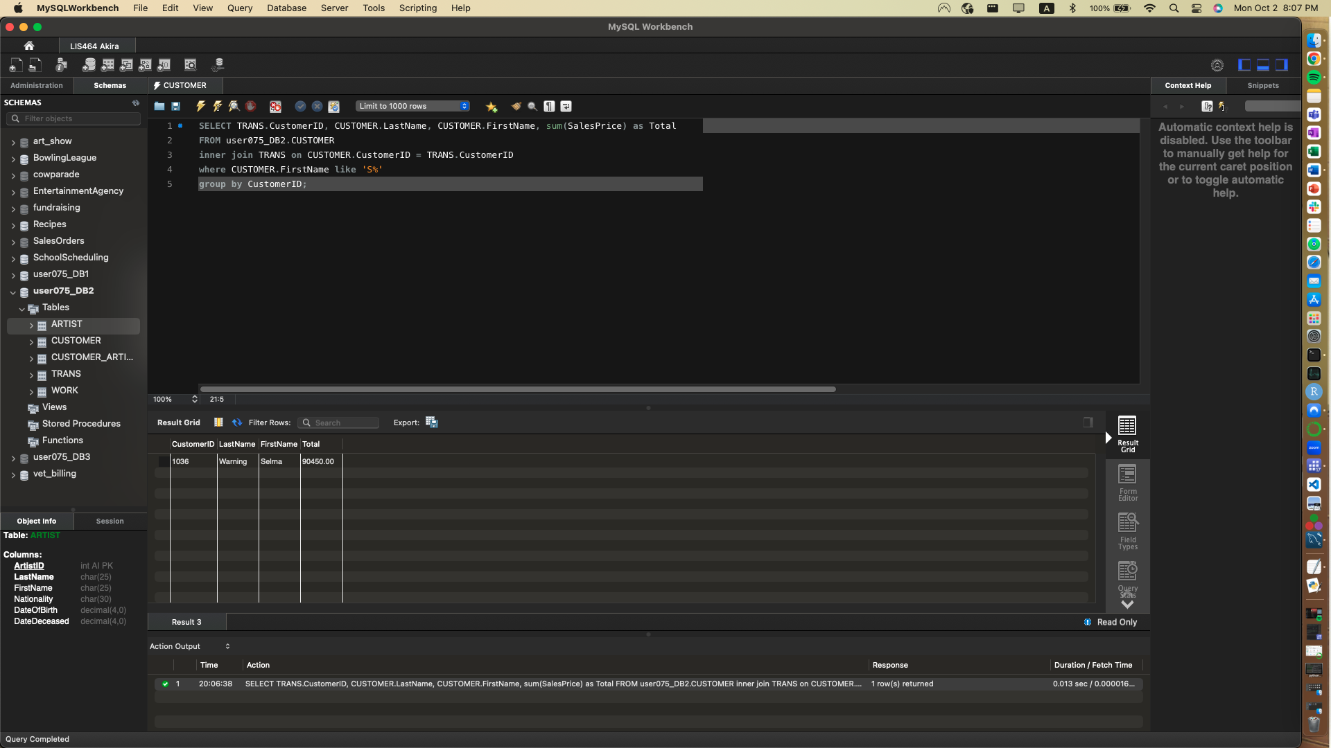

**Query 3.2: (Using RECIPES on Akira) Show me all the recipe titles of recipes that contain either beef or garlic (note beef = 1 and garlic =9) 5 rows.**



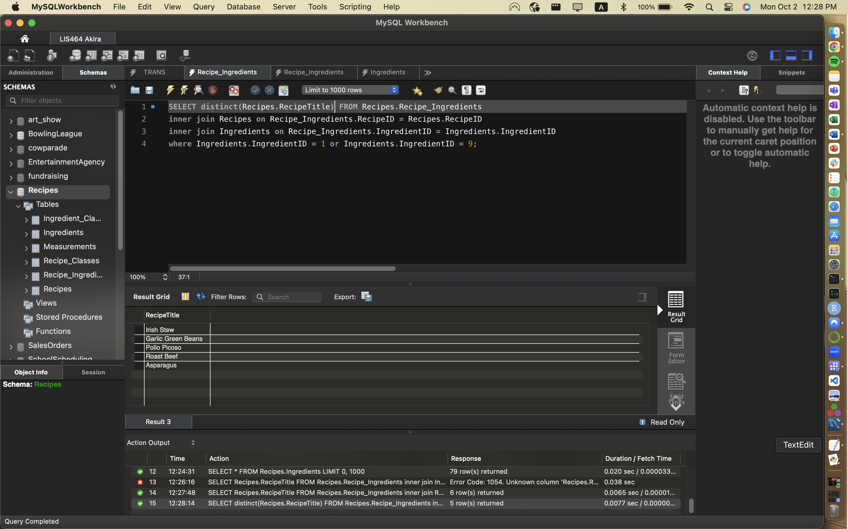

**Query 3.3: (School Scheduling” database on Akira) -** **List every class and its subject name (not just the subject ID!) Then delimit to only the list to the following subject areas (Design, Introduction to Art, Drawing, Painting and Art History). 7 rows.**

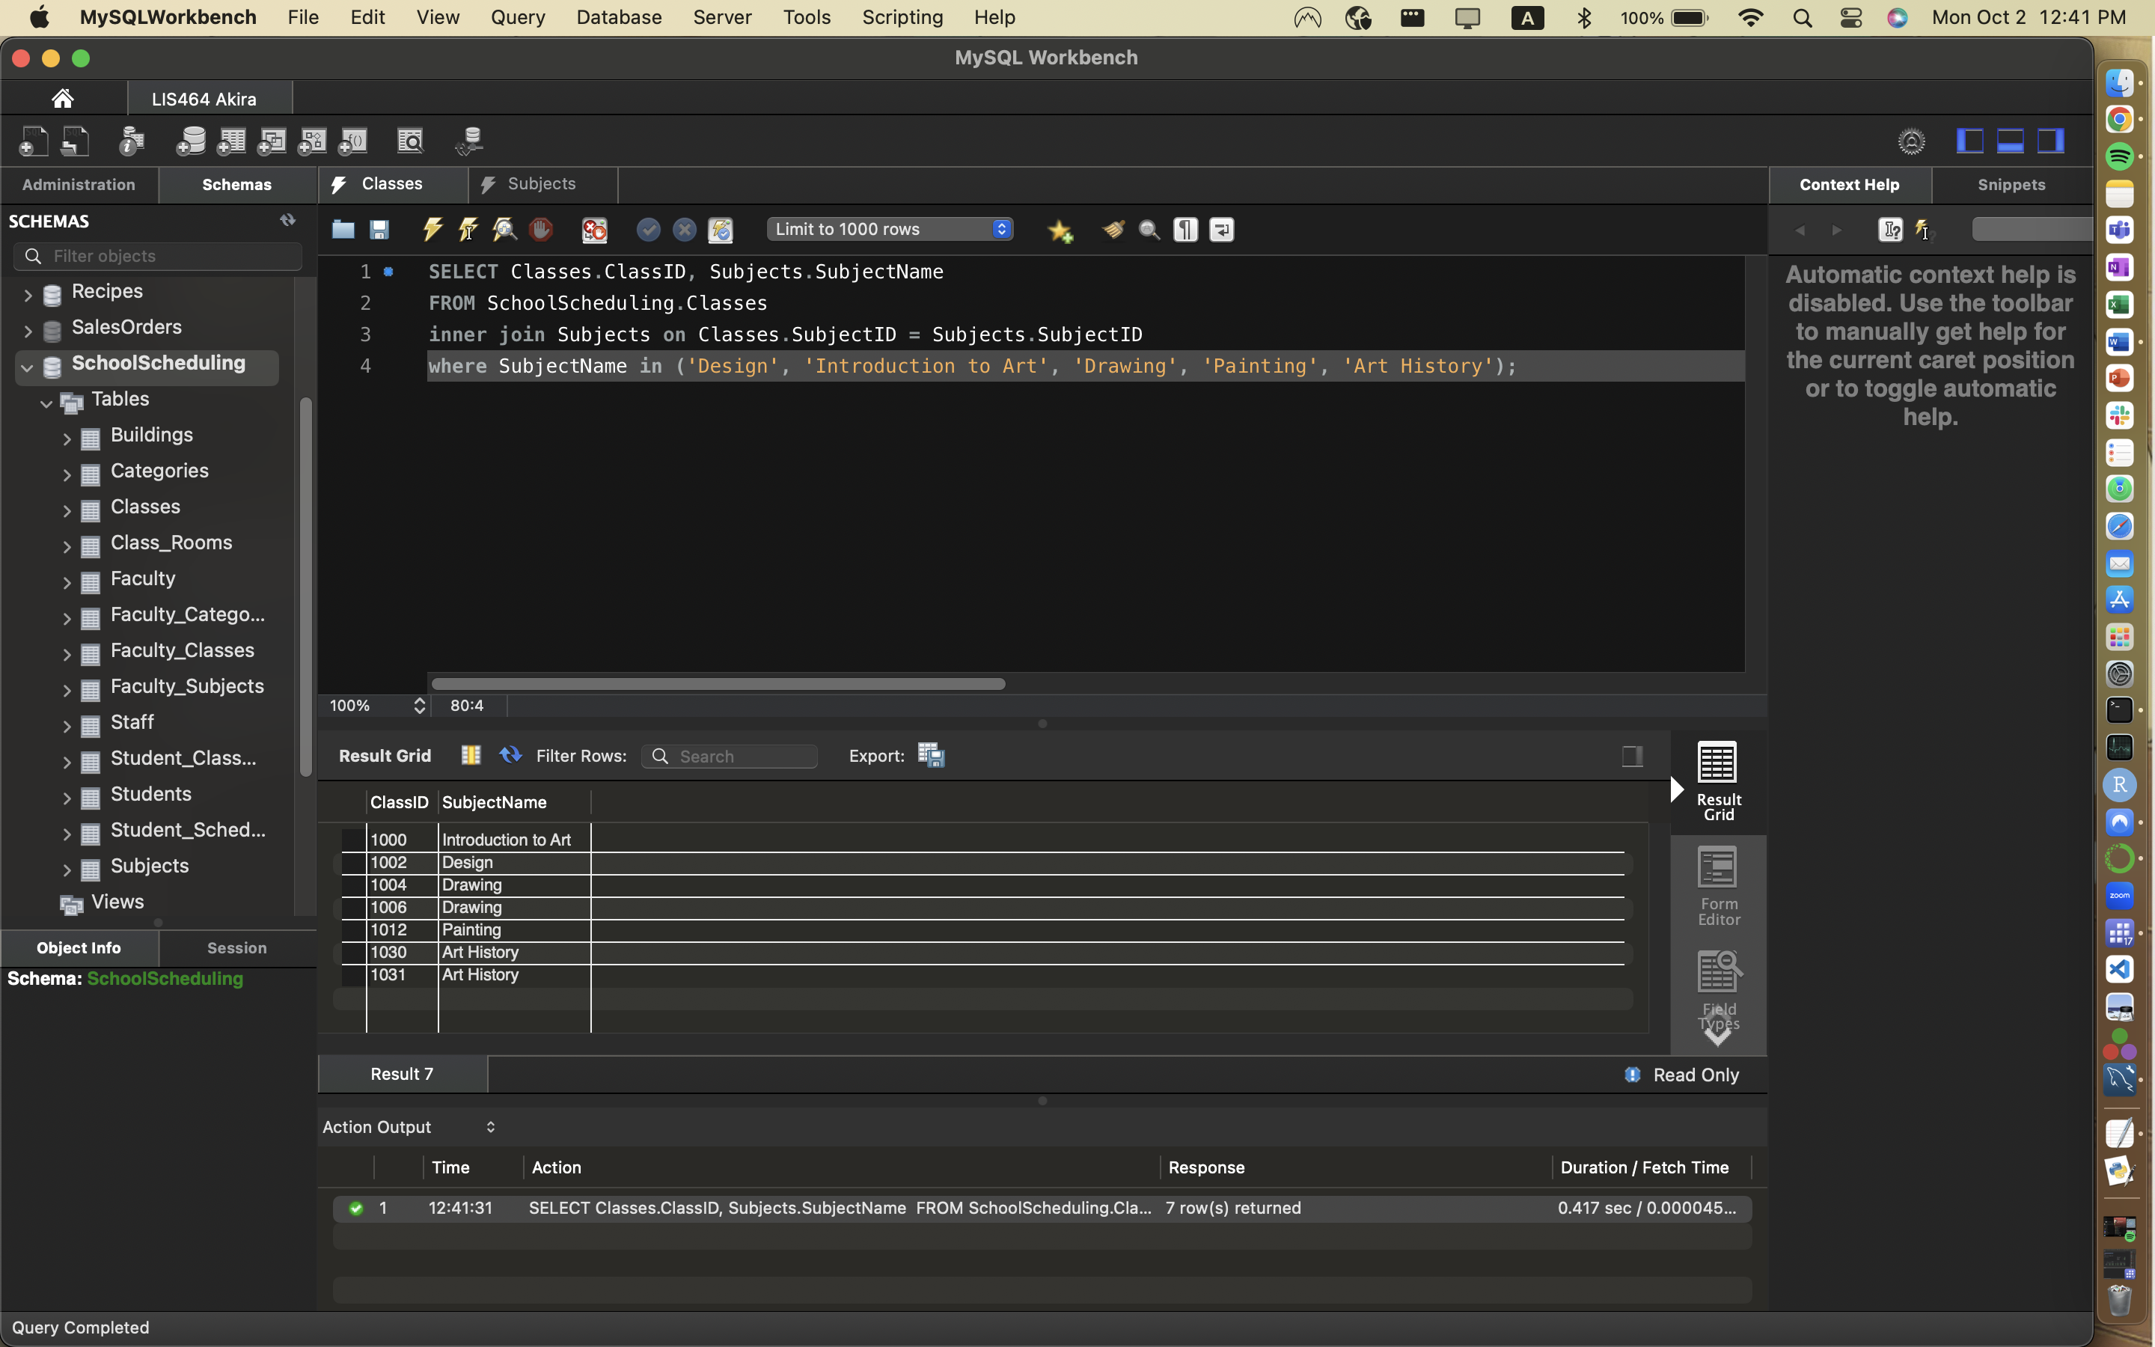

## Problem Set 4: Aggregate Functions with Group BY and HAVING practice with 2 tables

We use GROUP BY and HAVING when we use AGGREGATE functions such as SUM, AVG and COUNT. In this section we practice recognizing that an aggregate function is needed and adding the GROUP BY and HAVING clauses when necessary.

GROUP BY/HAVING cheat sheet –

<https://www.codecademy.com/learn/learn-sql/modules/learn-sql-aggregate-functions/cheatsheet>

**Query 4.1: (Use Bowing League - Bowler-bowler team)** **List every bowlers name and their average score from all their listed games.  Order from highest to lowest average score. (Hint use GROUP BY)** 32 rows

Hint – watch out for people with the same last name.

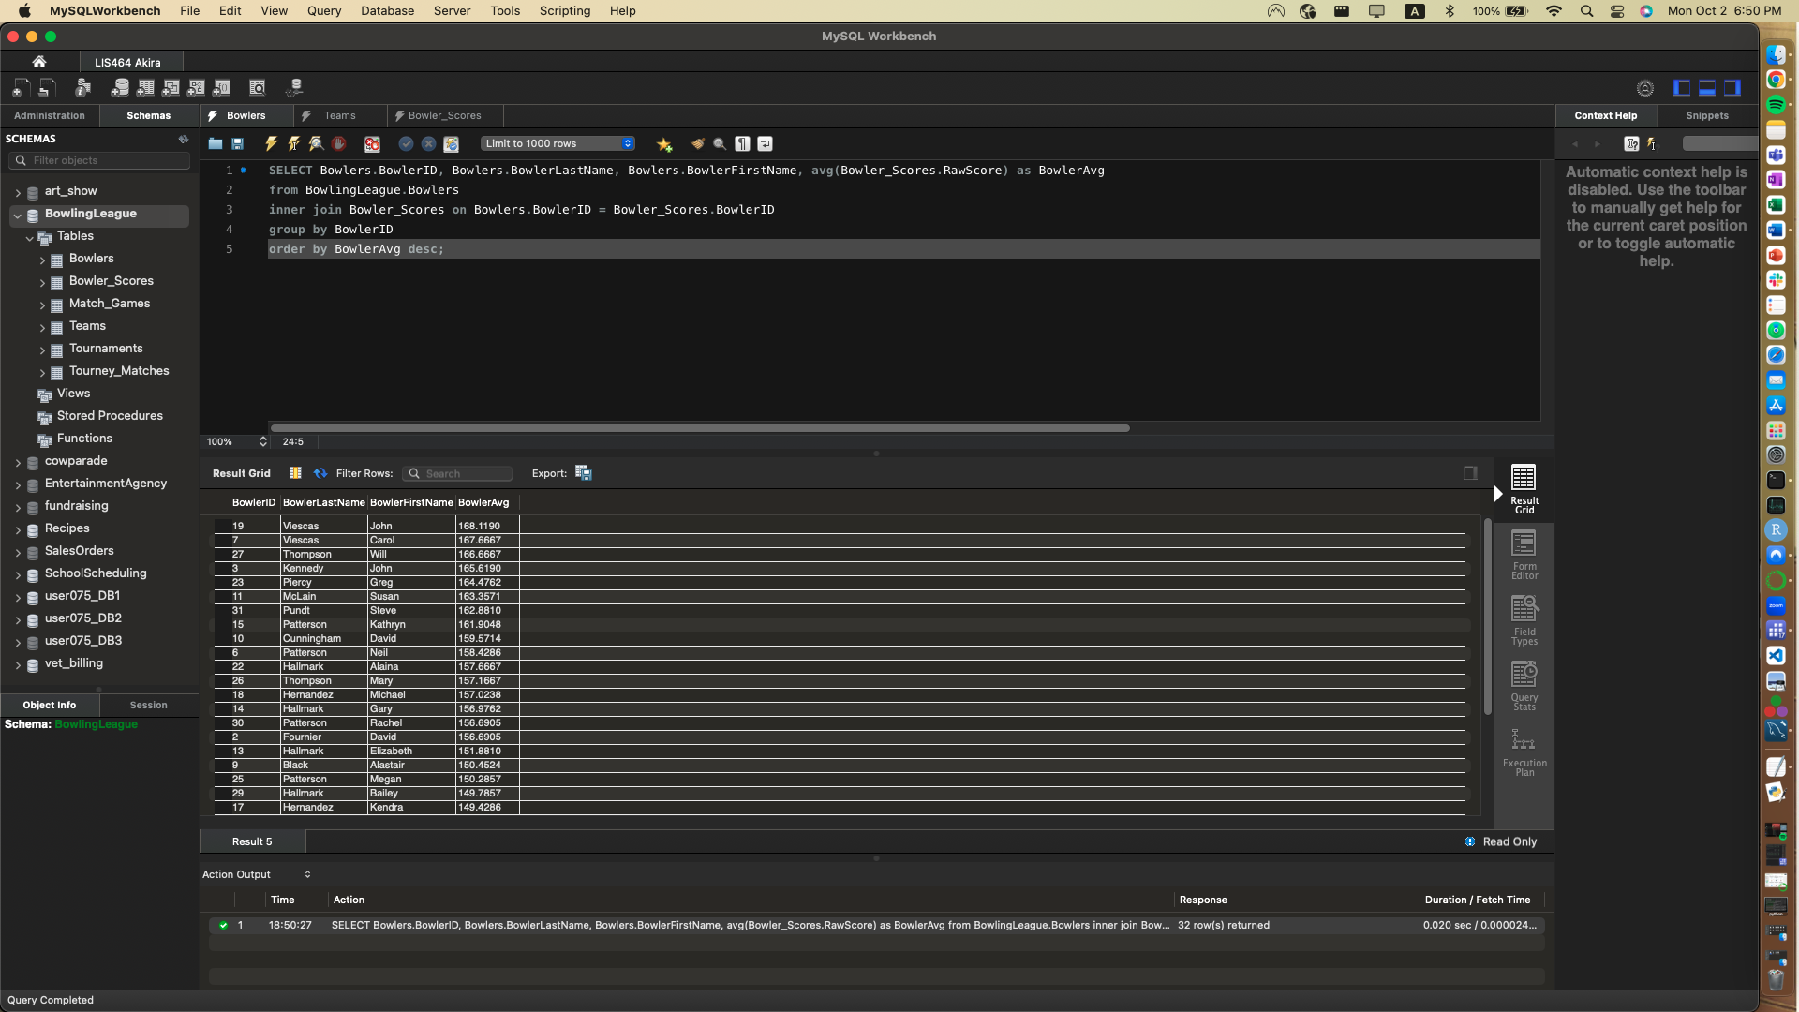

**QUERY 4.2: (use School Scheduling) How many classes (COUNT) does each subject area get within the curriculum of the school? Order most to least. (Hint use GROUP BY) 53 rows**

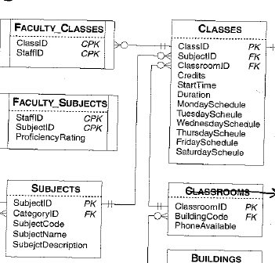

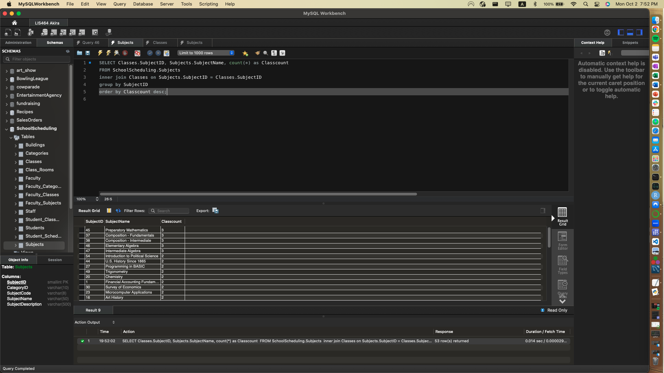

**Query 4.3: (VRG database from Lab 3) Please list number of works (COUNT) by each artist at VRG. Please use the first and last name to present each artist. (Use GROUP BY) 9 rows.**

Hints: <https://www.w3schools.com/sql/sql_count_avg_sum.asp>;

